The Covid- 9 pandemic hit the country around 9th March and a National lockdown put paid to much of the OAGS calendar. Once golf was allowed to be played with restrictions, it allowed some games to take place under strict rules.

OAGS v. Aldeburgh Golf Club - 15th February 2020
Win: OAGS 10 – Aldeburgh GC. 2

The Old Amplefordians delivered another punishing victory to Aldeburgh for 2020. Aldeburgh advised before play that they would be turning up with a more youthful and skilful team for the 2020 fixture but somehow they underestimated the skill and power of the Old Amplefordians. We also turned up with a relatively young side and ran riot in the morning and afternoon.

The lunch provided was, as always at Aldeburgh, delightful and enjoyed by all. The Aldeburgh and Ampleforth team followed up the event by meeting for some friendly beers later that evening at the White Hart Inn.

It was not long after this that Covid pandemic struck and this was the only fixture that was played under usual conditions.

Thank you to all who attended and I look forward to another crushing win for Ampleforth in 2021 when hopefully the restrictions will be lifted.

Players: Sam Moon, Hugo Barnard, Joe Ainscough, Max Bonavia’ Patrick Faulkner, Will Theile

OAGS Tour de Espana March 2020

Despite play being halted after two of the three scheduled competition rounds, due to the onset of premature lockdown in Spain so we thought, it didn’t dampen spirits with also lots of fine golf being played. The tour was given a last minute boost by the surprise arrival of William Frewen who managed to escape from Cheltenham in one piece.
The tournament leader by two points from the host was Matt Camacho with Alex Faulkner and Pierre Van Houtte lurking only a further point behind, the latter after a fine round of 27 scratch stableford points on a tough testing La Reserva.
The annual putting competition which invariably seems to provide a surprise winner was won by Matt Camacho.
The joint leaders in the nett competition were Will Thiele (subject a inquest with 15 clubs in the bag) and Pierre Van Houtte.
The prestigious wooden spoon competition was being hotly contested by Chris Healy, Sam Moon and Lucas Domecq.
And the specials....
Duke of Norfolk award…Simon Hardy four clear of George Hattrell
Rookie of the year…Marcos Morenes
Leading House…St Cuthbert`s
Roll on 2021 Tour!! Mark Whittaker

Photo taken at La Reserva Golf and Country Club:
Standing left to right;
Chris Healy, Lucas Domecq, William Frewen, Simon Hardy,Christian Minchella, William Theile, Joe Ainscough
George Hattrell, Patrick Faulkner, Pierre Van Houtte, Martin Hattrell
Crouching left to right:
Alexander Faulkner, Marcos Morenes Beltran, Mark Whittaker,Matthew Camacho, Sam Moon

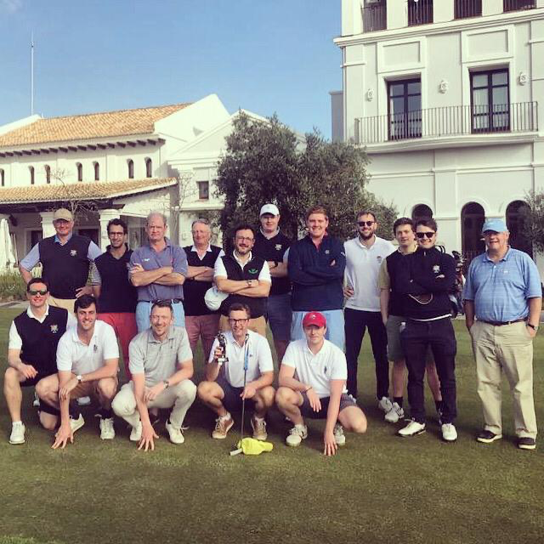

Russell Bowl – Woking GC on 25th July 2020

Another fabulous day at Woking GC, at an unusual time of the year for the RB. The Old Amplefordians were dealt an early blow with the late withdrawal of a team member due to injury (bad back), however the stoicism of the Amplefordian spirit shone through with the very late call-ups of William Frewen (morning only) and Simon Murphy (afternoon). William was getting out of bed on Sunday morning when the SOS came through, and having done a test walk up the street, was {self-assessed} passed fit to play.

Conditions were ideal (warm early-September sunshine) and the course was in great conditions, especially amazing given the circumstance of the year. The OAs secured 2nd place at lunch, but were quite some way behind the St George's side who had fielded their Grafton Morrish side as this was going to be their prep heading into the September event in Norfolk.

After a typically nourishing lunch, albeit socially distanced, the OAs carried on in similar fashion to their morning round. Just a 1-point difference separated the morning & afternoon totals by the OA, and how important that point was given that 1-point ended up separating us from a 3rd place Worth side.

The OAs will need to field a side with some Grafton Morrish members next year if we are to stand a chance of competing with a very strong St George's side. There is certainly now an incentive for the Society's best to show face, and use this competition as a means to trialling members for places in the big events of the OAGS calendar.

Morning Pairs Afternoon pairs
Healy & O'Connor (25 points) Faulkner & O’Connor (26 points)
Faulkner & Coysh (25 points) Heagerty & Healy (19 points)
Heagerty & Frewen (10 points) Coysh & Murphy (16 points)

Results:
1st - St George's Weybridge - 162 points
2nd - Ampleforth - 121 points
3rd - Worth - 120 points
4th - Downside - 101 points

Next RB is scheduled for 25 July 2021.

OAGS Northumberland Meeting – 11/12th September 2020.

We had an enjoyable meeting in Northumberland on the 11th and 12th September with 7 golfers at Bamburgh (Mark and Jack Whittaker, Hugh Myers, Christian Shepherd, Jonathan, Ben and Sam Brown) and 8 golfers at Goswick with Tim Myles joining for the day.
Both games were played in high winds although the scoring from the lower handicap golfers remained good, as one might expect. Leading the way at Bamburgh (par 68) was Sam Brown on 34 stableford points and Hugh Myers on 33 points. All golfers enjoyed the stunning views Bamburgh has to offer.
At Goswick (par 72), a qualifying course for The Open when held at Muirfield and a tougher test than beautiful Bamburgh, Hugh shot a very good 35 points (78 gross), with Mark 33 on points (77 gross). Impressive golf in winds gusting over 30mph. The top gross match went to the last with Mark birdying the last. Tim Myles should also be mentioned in despatches for an excellent round, scoring 32 points.
Hugh Jackson won over the two days with 68 stableford points, followed by Mark on 62 and Sam, 57
Hopefully, post-covid, the meeting in June 2021 will see more OAGS members enjoy the delights of the Northumberland coast.
OAGS Autumn Meeting at Ganton – 3rd/4th October 2020

Friday 2nd October – OAGS v Old Sedberghians - cancelled

Saturday 3rd October – OAGS Singles

With Covid taking its toll on a large majority of OA golf fixtures for 2020, it was such great news to be able to hold this year’s Autumn Meeting. The response was very encouraging, and at one point there were twenty- one golfers turning up over the weekend!

Heavy and persistent rain was to greet all fourteen OA’s for this year’s meeting with a mixture of regulars and new faces. Waterproofs, umbrellas plus anything else to keep all golfers dry by the end of the morning rounds were a must. Even our on course commentator lasted to the 16th hole having got soaked!!

The quality of golf was at a very high standard especially from our Halford Hewitt Captain Mark Whittaker shooting a four over par/32 points and taking the Ganton Driving Mashie.
The Ampleforth Bowl was won by James Rayner with a great round of 32 points and winning on a three hole countback. The Palengat Cup was retained once more by Charles Jackson with a very steady 32 points. (I was told the short game was very solid, again).

It was decided amongst all golfers at lunch, that the afternoon Foursomes would be postponed for this year. The weather had done the damage in the morning’s play. A short presentation to all the Winners followed, and no evening Supper arrangements were made again due to Covid restrictions.

Winners:

Ganton Driving Mashie [Singles Scratch]: Winner – Mark Whittaker (32)
Ampleforth Bowl [Singles Hcp]: Winner – James Rayner (32) on a count back.
Palengat Cup [Singles over 60]: Winner – Charles Jackson (32)

Sunday 4th October - Sadly, due to Covid the fixture had to be cancelled.

Players on the Saturday were:
Christian Minchella, Hugh Jackson, Ed Robinson, Damien Mullen, Guy Henderson, Bill Browne, James Raynar, Charles Jackson, Mark Whittaker, Christian Shepherd, Alex Cuppage, Matt Rotherham, John Greenan, Henry Swarbrick and Robin Andrews.

Ramsgate Jubilee Niblick – Hunstanton/Brancaster - 10/11th October

After a gap of many years, and despite the Covid restictions, Simon Hardy arranged for the Ramsgate Jubilee Niblick to be contested

It was played for by eight intrepid OA’S competing at Hunstanton and Brancaster.
Teams of four led by Edward Kitson and Hugh Jackson battled it out, sometimes in less than clement weather, but it was great fun:

Team Kitson: Edward Kitson; Simon Hardy; Mark Whittaker; Matthew Camacho (putting only)
Team Jackson: Hugh Jackson; Martin Hattrell; George Hattrell; Will Theille

The result after 54 Holes was 8:4 in favour of the Kitson team based on holes up.

It is hoped to try and fit this fixture back into the OAGS calendar.

OAGS v OACC at Woking GC ( Brennan Cup) - 17th October 2020

Result: OAGS 5 ½ : OACC 4 ½

Despite the Covid restrictions, the annual end of season match between the OAGS and the OACC returned to Woking Golf Club on Saturday 17th October on a grey but dry and mild day. At the eleventh hour, John Gibbs was unable to join us but it was good to see some new faces especially Hugh Myers, a promising young golfer who has just left SHAC. Piers Cartwright-Taylor was magnanimous in ‘batting’ for the OAGS in a neutral manner !

The stand-out performance in the morning came from the OACC with Toby Fitzherbert & Dom Spencer defeating Alex Faulkner & William Frewen 8&6. There was a good win for Mike Forsythe & Hugh Myers but with the OACC winning the other two matches, the OAGS trailed at lunch 3-2.

The afternoon saw some terrific matches, including half in the Chris Newsam/Hugh Myers verus Cerri Williams/Nick Lamb match but ultimately the OAGS manage to overcome the lunchtime deficit and win the remaining three matches to win back the Brennan Cup for the first time since 2017.

OAGS Pairings – Morning:
- Alex Faulkner & William Frewen – Lost
- Mike Forsythe & Hugh Myers – Won
- Mike Tibbatts & Nick North – Won
- Chris Newsam & Finbarr O'Connor – Lost
- Piers Cartwright-Taylor – Lost

OAGS Pairings – Afternoon:

- Mike Forsythe & William Frewen – Won
- Chris Newsam & Hugh Myers – Half
- Nick North & Finbarr O'Connor – Lost
- Alex Faulkner & Mike Tibbatts – Won
- Piers Cartwright-Taylor – Won

AGM meeting (Covid) at Royal Ashdown Forest – 24th October 2020

As we had been unable to meet for our AGM at the Spring meeting at Royal Ashdown (due to the pandemic), it was decided to convene a small AGM meeting under the ‘rule of six’ to finalise this unusual year and plan for 2021.

After a brief meeting with coffee & bacon roll, we were joined by a further six members and made up three 4balls groups to play Singles Full Stableford for the Raby Cup. Unusually, the Club had permitted 4ball as we were following a fairly large club competition.

The weather was squally, but the temperature was warm. We all managed to enjoy the round albeit at slightly slower pace but that gave us the chance to take in the wonderful autumn colours. The greens had been recently dressed but we sampled the new 7th green which extends the hardest hole (SI1) by some thirty yards.

Alex Codrington invited his brother Toby from Singapore as guest. We all felt quite hungry so settled on the special round table for a welcome ham egg & chips.

Congratulations to Chris Newsam for winning the Raby Cup with a creditable score of 36.

We hope that we will see many more OAGS members in May 2021 to play for all the other trophies.

Raby Cup: (Singles Stableford) – Chris Newsam (36)

Players: John Gibbs; Finbarr O’Connor ; Nick North; Alex Cuppage; Chris Newsam; Philip Quigley; Nick Price; Will Theile; Alex Codrington; Toby Codrington (guest)

